### Technical Design Document Template

***Rush Hour***

***Elevator Pitch:***

The game is a 2D top down game which is controlled purely by the ai. This game will involve robbers, police. The game will involve the robbers running around the map to find and collect money bags. The police will be wandering around the map. If they see a robber, they will chase after them. If the robber is caught, they disappear from the map and would not be able to continue stealing from the police. The ai needs to get as many money bags as possible before they get caught.

These agents or characters will have the following:

**Robbers:**

* Follow Path
  + This follow path will be for getting to a certain location in the map. To collect money bags
  + The follow path will occur until the police is within distance of the robber.
  + The flee behaviour will then be implemented when the police are around
* Flee Behaviour
  + This flee behaviour will occur when the robbers are spotted by the police.
  + It will continually flee until the police are out of range of the robber. It will revert to follow path afterwards.

**Police:**

* Wander Behaviour
  + The wander behaviour will move the police around the map at random.
  + This behaviour will continue until the police are within range of the robbers. When this occurs, the seek behaviour will occur.
* Seek Behaviour
  + The seek behaviour will occur when the police are within range of the robber.
  + The police will seek towards the robber until they caught them.
  + When the robber is caught, or they are out of range, the police will be return back to a wandering behaviour.

**1.0 Revision History**

|  |  |
| --- | --- |
| Version | Description |
| 1.0 | Initial Document |
| 2.0 | Final Document |

**2.0 Development Environment:**

**2.1 Game Engine**

N/A

**2.2 IDE**

Microsoft Visual studio

**2.3 Source Control**

Git

**2.4 Third Party Libraries**

Raylib

**2.5 Other Software**

Tiled

**Diagram of the police and Robber behaviours within the game.**

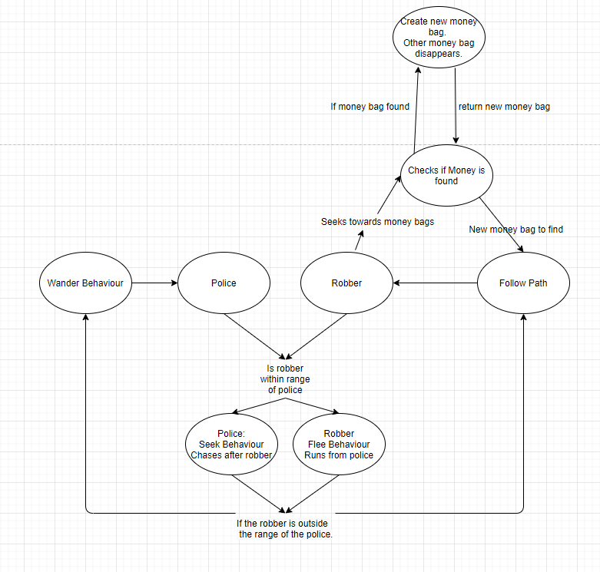

**7.0 Physics**

In terms of interactions, if the robber comes within the radius of the police, the robber will use the flee behaviour to run away from the police whilst the police will use the seek behaviour to run towards the robber. As the robber is slower than the police, the police will eventually catch the robber. When the robber is out of the radius of the police, the robber will return to their path finding algorithm to find the money bags. When the police capture the robber, the robber will disappear from the screen as they will be considered captured.

**11.0 Interface - Controls**

The player would be able to press tab to view all the nodes and movements that the robbers and police will be performing whilst the program is running.

**14.0 Asset List**

In relation to the Tiled software, I will be using certain tiles to make the map, the robber and the police.

***Third Party graphical implementations:***

* Evaluation of the framework’s suitability:
* Technical impact of the framework:
* Framework licensing, any licensing issues:

**Create a map of the project and insert it into the document.**